**Phase5 Final Project 1 Writeup**

**CI/CD Deployment for Springboot Application.**

DESCRIPTION

**Project Objective:**

As a Full Stack Developer, you have to build a CI/CD pipeline to demonstrate continuous deployment and host the application on AWS EC2 instance.

**Background of the problem statement:**

As the project is in the final stage, management has asked you to automate the integration and deployment of the web application. You are required to set up an environment where the application will be hosted and accessed by users. The source code is supposed to be fetched from a GitHub repository.

**You must use the following:**

* Eclipse
* GitHub
* S3 bucket
* AWS EC2/ Virtual machine

This section will guide you to:

* + Launch and connect to an EC2 instance

This lab has three subsections, namely:

1. Write spring boot program.
2. Launching an EC2 instance
3. Connecting to the EC2 instance
4. Creating S3 Bucket. 5.Added jar file in bucket.
5. Pushing the files to GitHub repositories

**Step 1: Write spring boot program:**

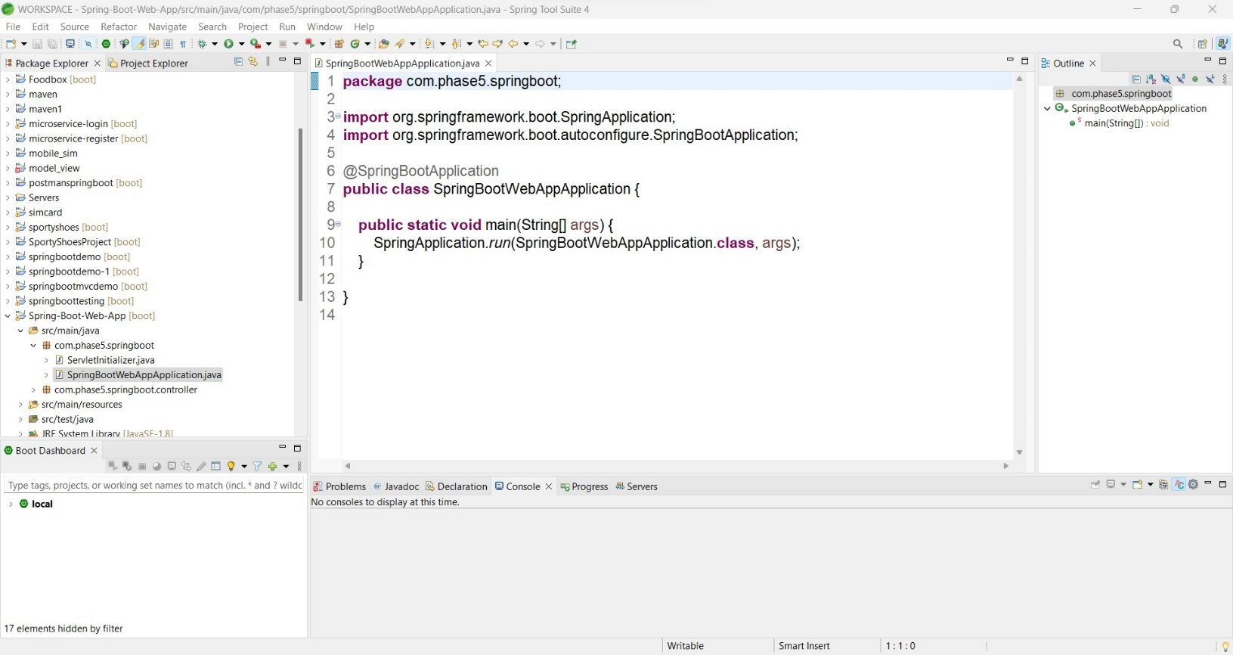

# Step 2: Launching EC2 instance:

1. Click on launch instance to run any instance
2. Select the AMI

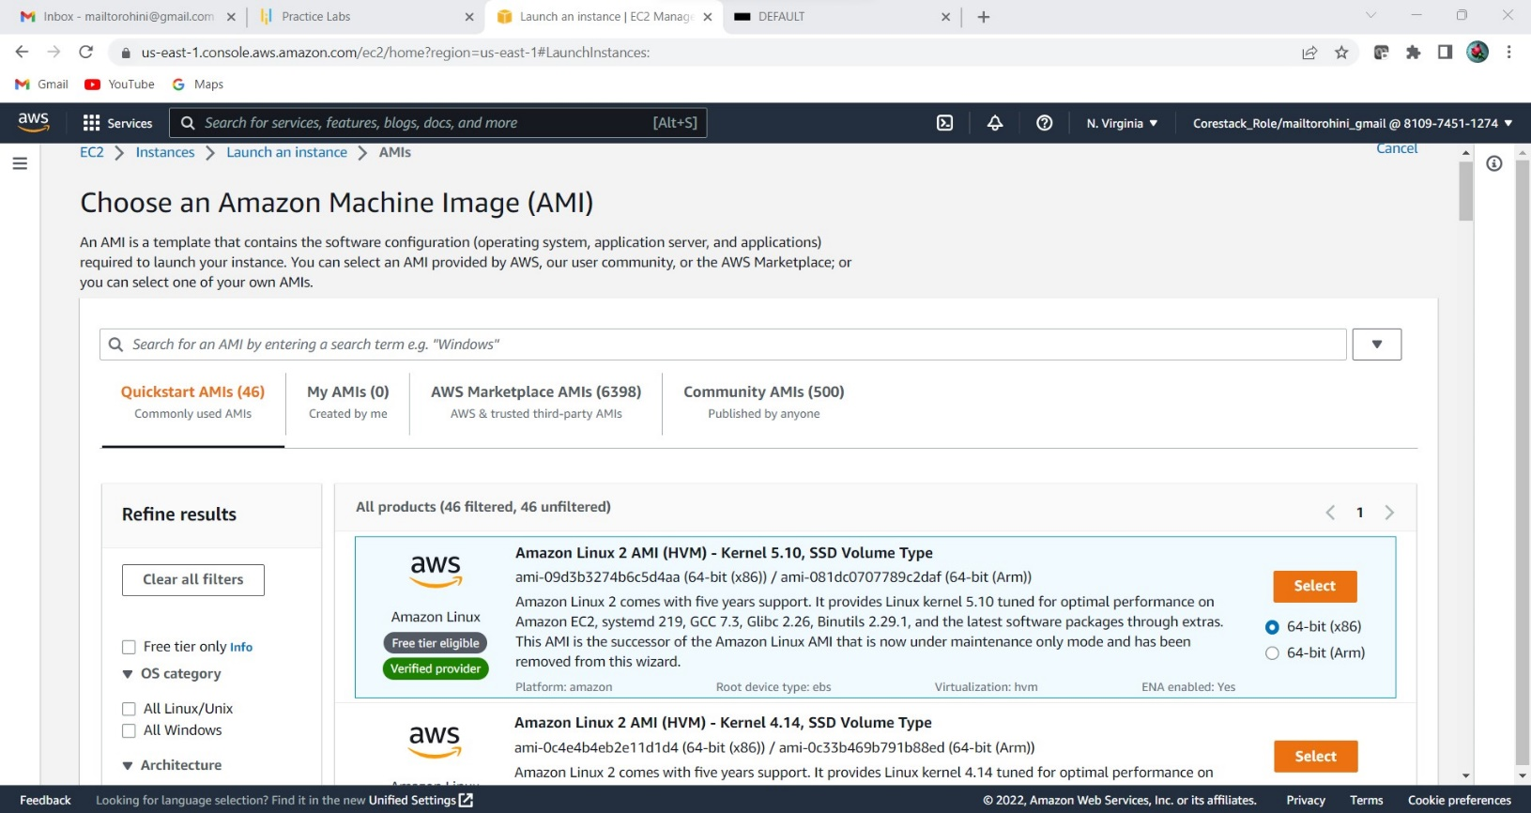

1. Select t2.micro as the instance type

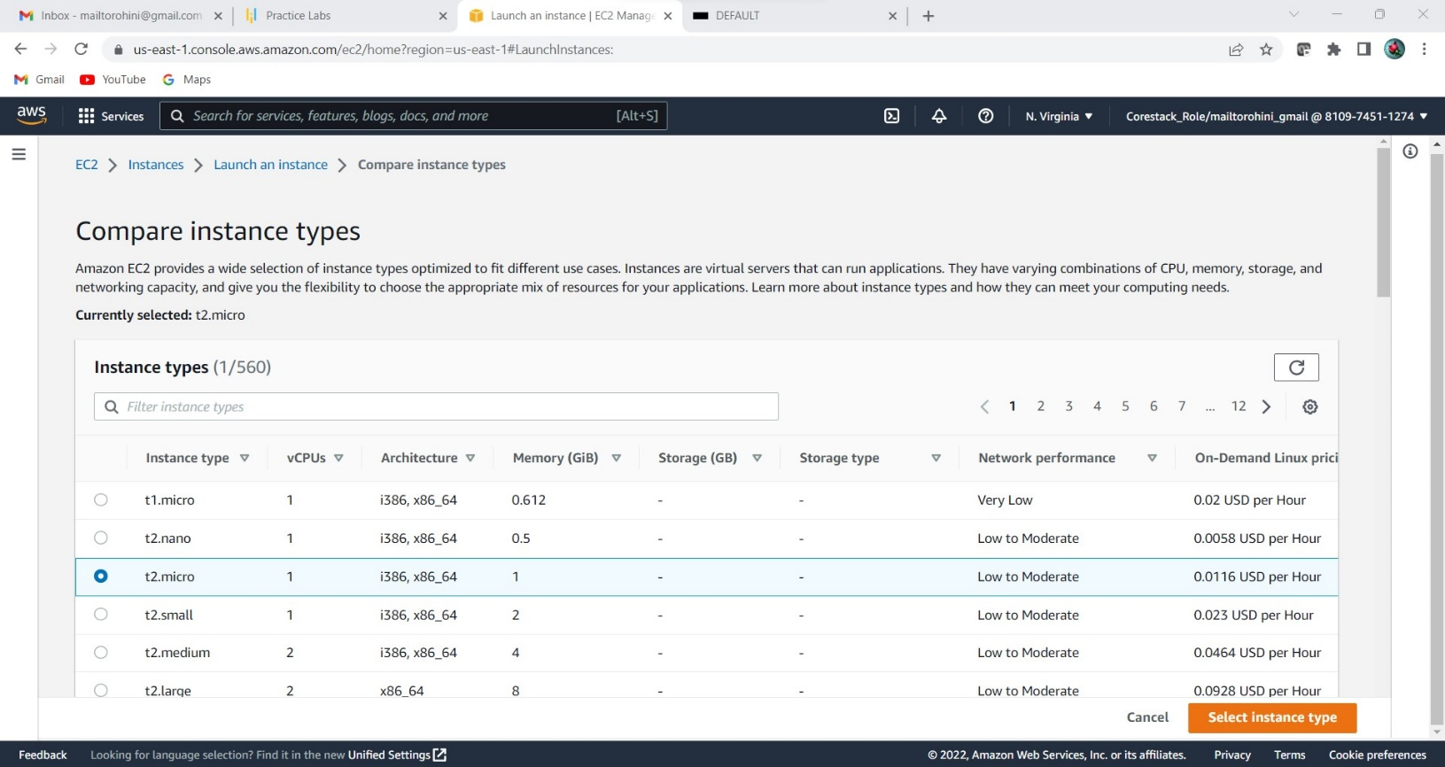

1. Specify the number of instances, networks, placement groups, and IAM roles and click Next

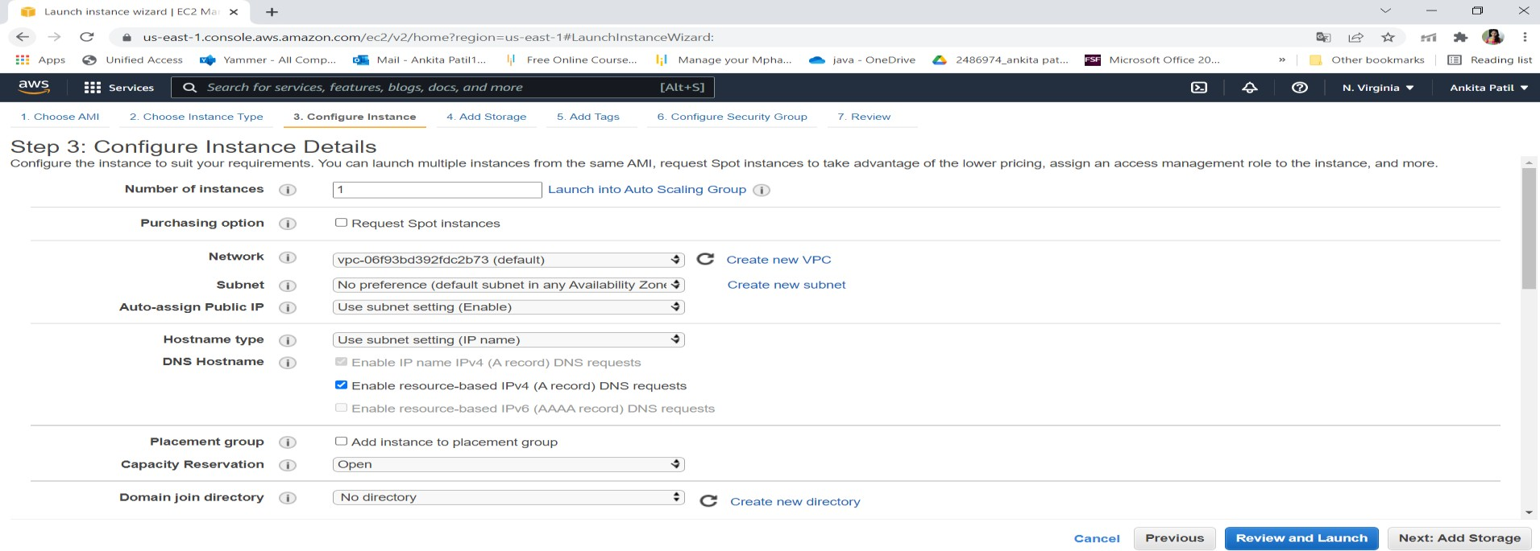

1. Add storage

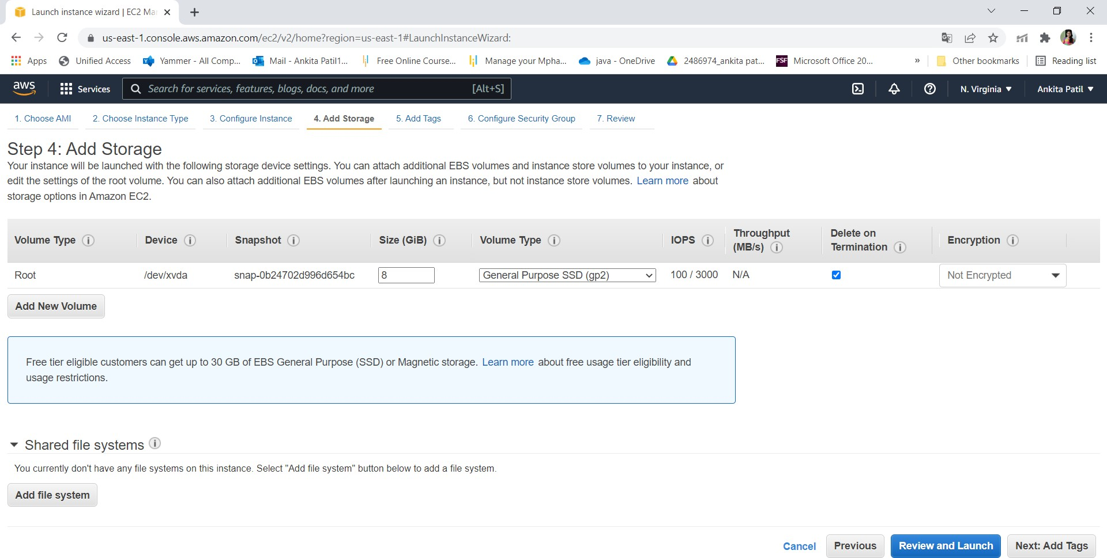

1. You can add a key-value pair to the instance

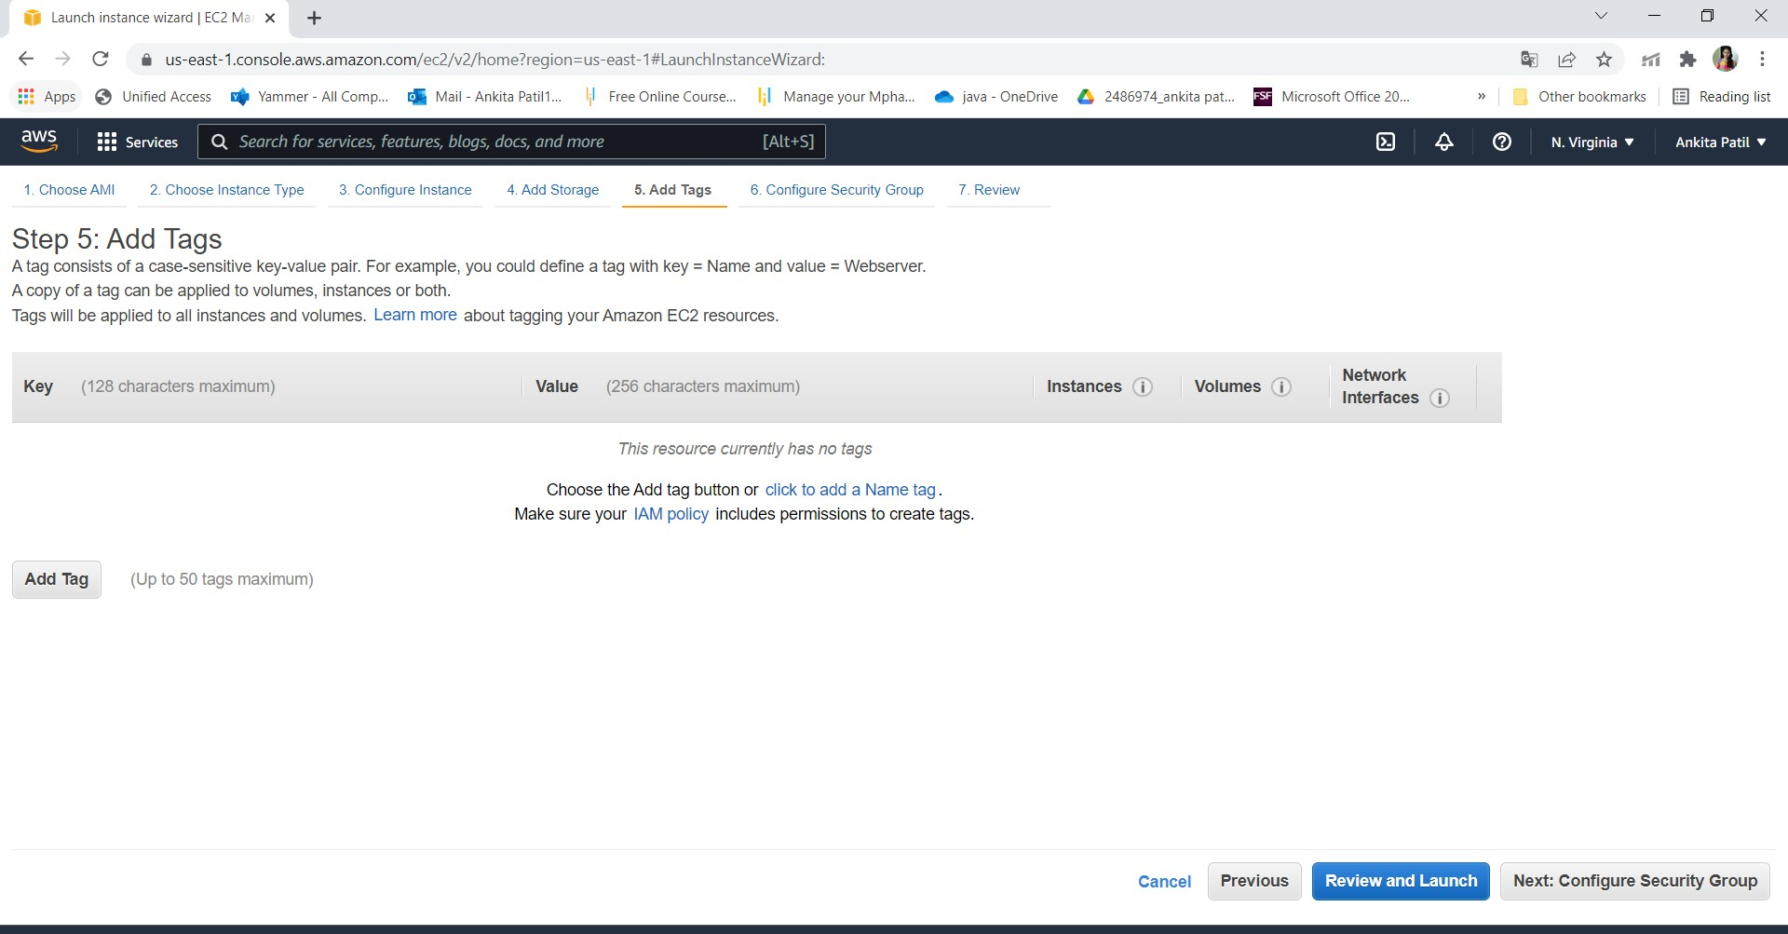

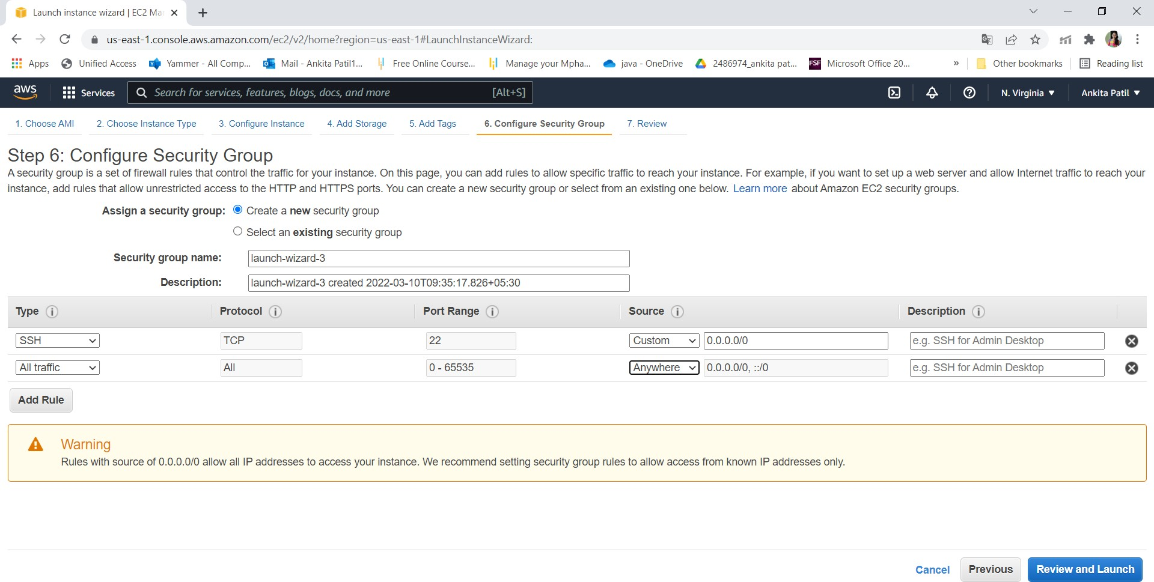

1. Click on launch

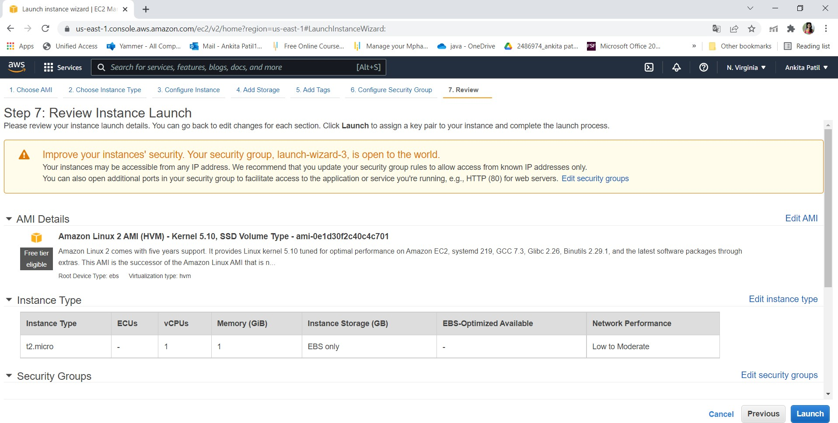

1. Create key pair

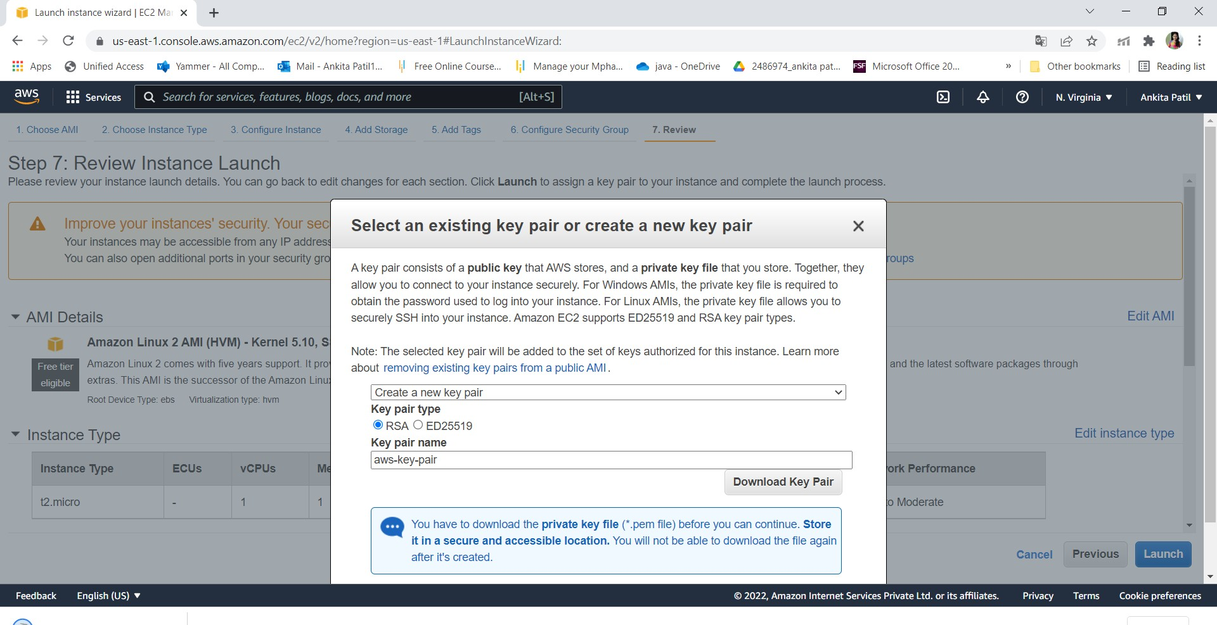

1. Click on view instance

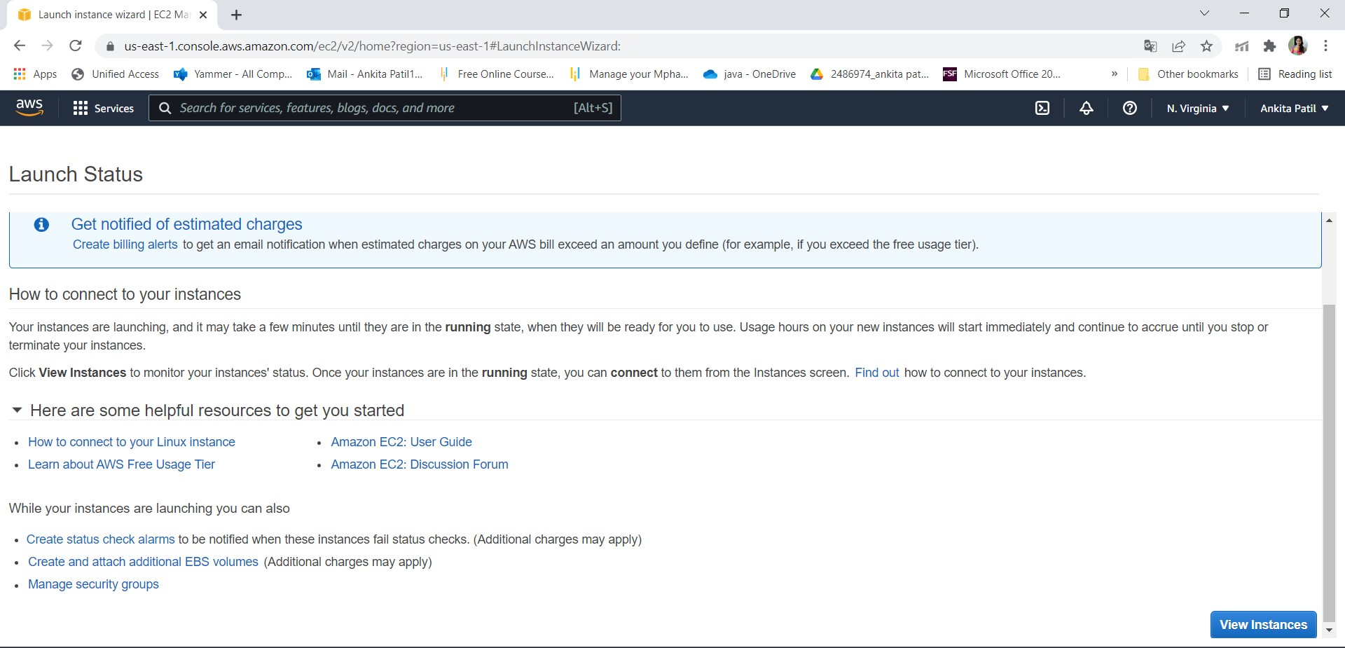

1. Connect the instance

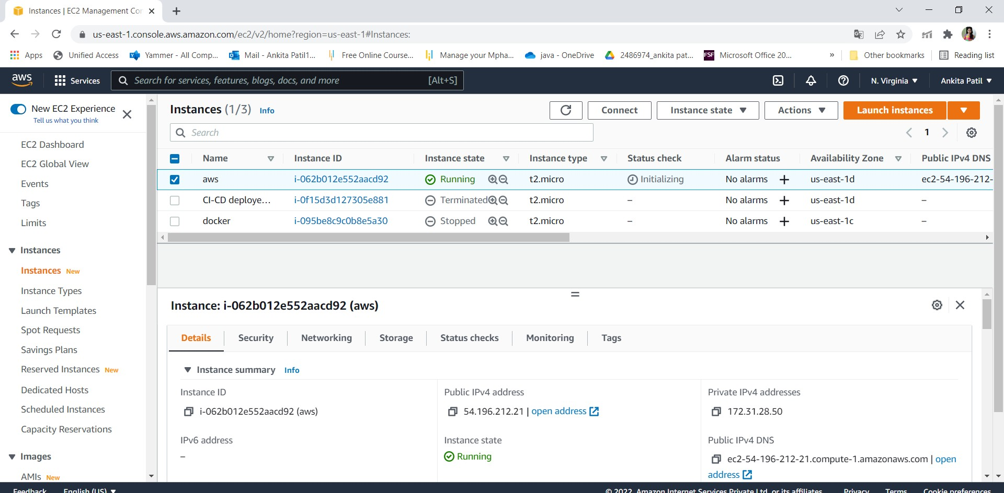

# Step 3: Connect to EC2 instances:

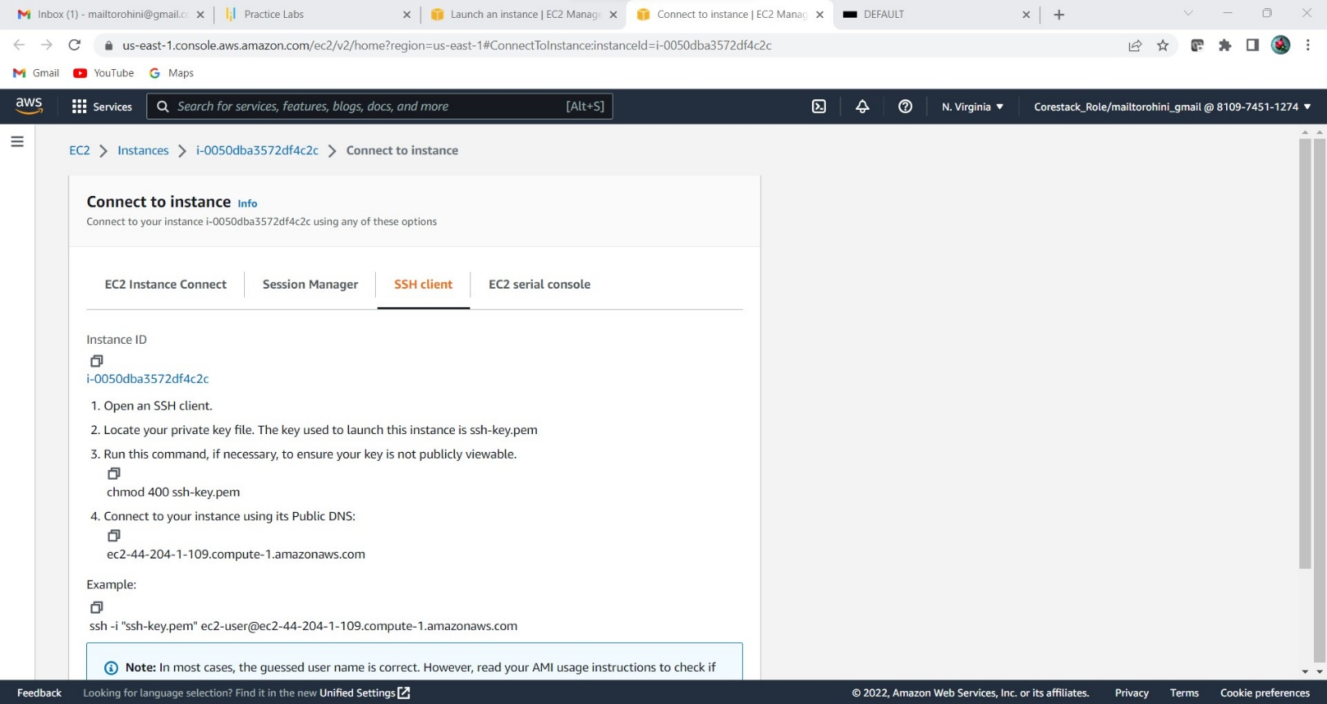

1. Click on Connect on EC2 dashboard & Run the ssh command provided

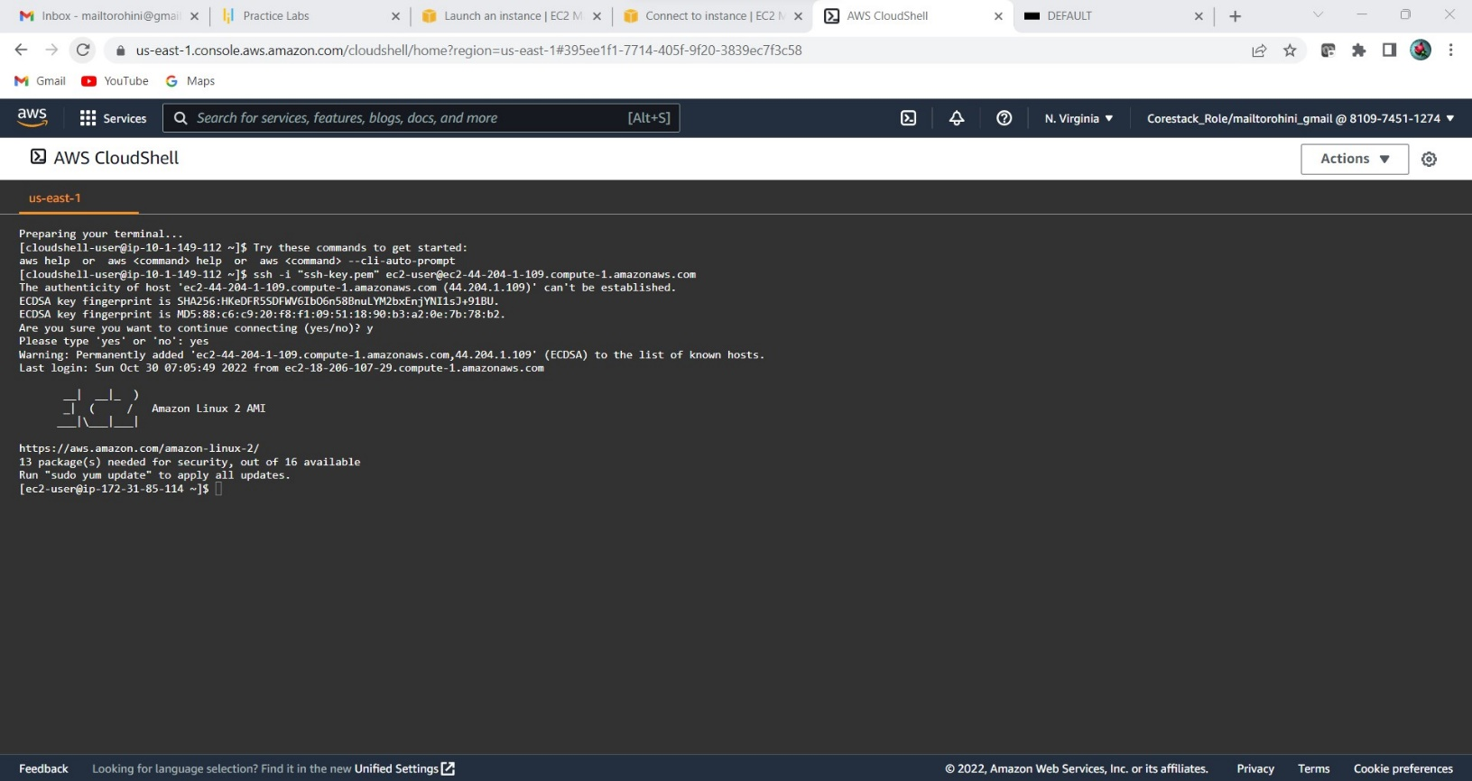

# Step 4: Creating S3 Bucket:

* 1. Create Bucket to store jar file:

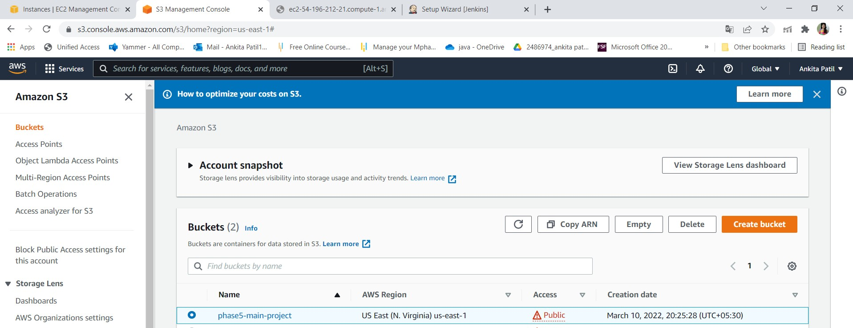

Step 5:Adding jar file:

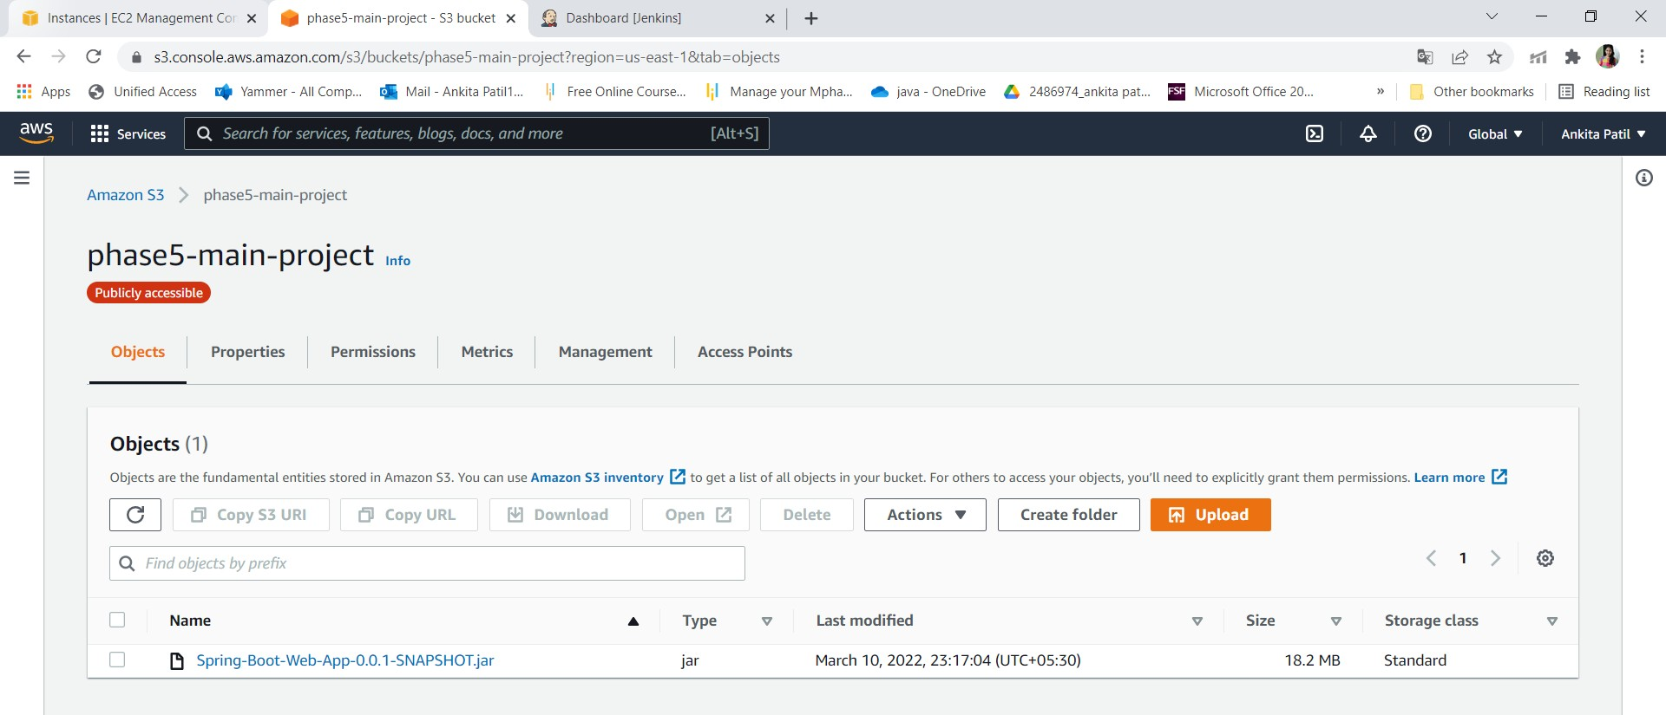

* + Run program through instance:

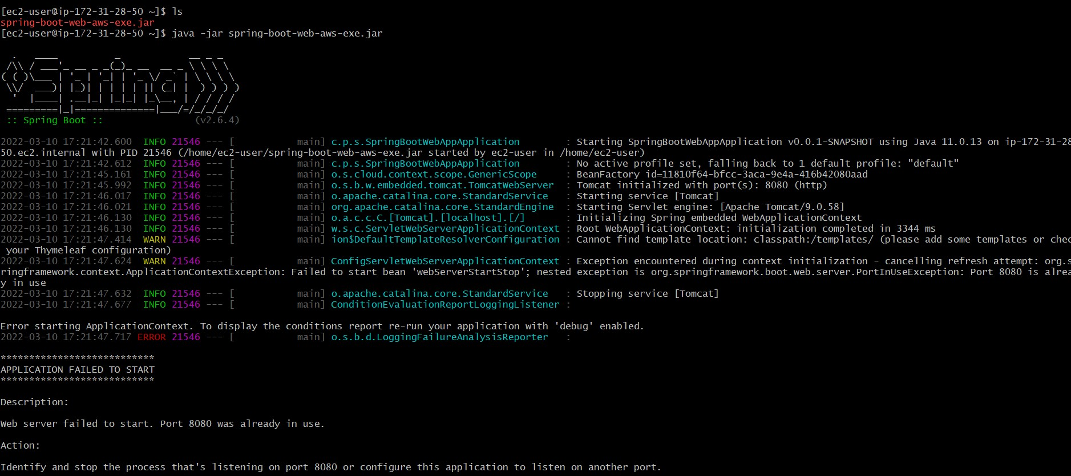

* + Output:

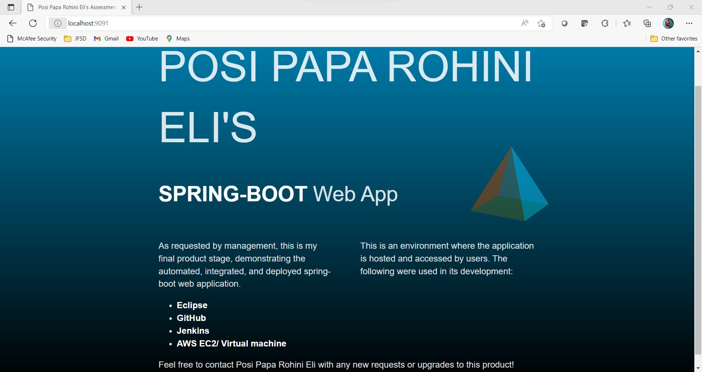

Step 6: Pushing the code to your GitHub repositories

* Open your command prompt and navigate to the folder where you

have created your files. cd <folder path>

* Initialize your repository using the following command:

git init

* Add all the files to your git repository using the following command:

git add .

* Commit the changes using the following command:

git commit . -m “Changes have been committed.”

* Push the files to the folder you initially created using the following

command:

git push -u origin master